**Fundamentals of databases**

**Customer Management system**

**Submitted By:**

**Muhammad Rebal Ahmed [19L-1404]**

**Hafiz Ahmad [19L-1316]**

**Introduction:**

The Customer Management System (CMS) project aims to streamline and enhance customer interactions, sales, and order management for businesses. The system includes features for user registration, order processing, inventory management, and feedback collection. By integrating these functionalities, the CMS facilitates efficient customer relationship management and business operations.

**Problem Analysis:**

**Data Fragmentation:**

The existing system lacks a centralized database, leading to data fragmentation. Customer information, sales, and order details are scattered across multiple tables, hindering a unified view and efficient data retrieval.

**Limited User Management:**

The user management system is split between 'User_Registration' and 'Users' tables, resulting in redundancy and potential inconsistencies. There's a need for a consolidated user management approach.

**Incomplete Transaction Logging:**

The 'Transactions' table lacks details about the nature of transactions, making it challenging to understand the context behind each entry.

**Lack of Item-Category Association:**

The 'Items' table does not directly associate items with categories, limiting the ability to analyze and categorize products effectively.

**Design Requirements:**

**Centralized User Management:**

Merge 'User-Registration' and 'Users' tables for a unified user management system.

Implement role-based access controls for enhanced security.

**Enhanced Transaction Logging:**

Enrich the 'Transactions' table with detailed information about each transaction, including context and user details.

**Item-Category Association:**

Introduce a 'CATEMST' table to manage item categories.

Update 'Items' and 'Sellers' tables to associate items with categories.

**Streamlined Order Processing:**

Refine the order creation process by introducing stored procedures for transaction and order insertion.

**Seller Management:**

Modify the 'Sellers' table to include a 'Status' column for better management of seller accounts.

**Implement a procedure for changing seller passwords.**

**Feasibility Analysis:**

**Technical Feasibility:**

The proposed changes can be implemented using SQL Server. Compatibility with the existing infrastructure is feasible. Stored procedures and views can enhance data retrieval and management.

**Operational Feasibility:**

Users may experience a learning curve with the updated system, but comprehensive documentation and training can mitigate this.

**Possible Solutions:**

**Database Normalization:**

Normalize the database to eliminate redundancy and improve data integrity.

Introduce foreign keys and relationships between tables for consistency.

**Stored Procedures and Views:**

Utilize stored procedures for complex transactions and views for simplified data retrieval.

Enhance performance and maintainability.

**User Interface Enhancements:**

Consider upgrading the user interface to align with the backend changes.

Ensure a seamless user experience during and after the implementation.

**Data Base:**

**use DB**

-- User Registration Table

CREATE TABLE User_Registration (

UserId INT PRIMARY KEY IDENTITY(1,1),

Name NVARCHAR(50) NOT NULL,

Surname NVARCHAR(50) NOT NULL,

Address NVARCHAR(255) NOT NULL,

City NVARCHAR(50) NOT NULL,

Pincode INT NOT NULL,

Gender NVARCHAR(10) NOT NULL,

Mobile NVARCHAR(10) NOT NULL,

Email NVARCHAR(255) NOT NULL,

Password NVARCHAR(50) NOT NULL

);

-- Users Table

CREATE TABLE Users (

UserID INT PRIMARY KEY,

Name VARCHAR(255) NOT NULL,

Age INT,

Username VARCHAR(255) NOT NULL,

Password VARCHAR(255) NOT NULL

);

-- Sellers Table

CREATE TABLE Sellers (

SellerID INT PRIMARY KEY,

UserID INT UNIQUE,

Category VARCHAR(255),

Status VARCHAR(50) NOT NULL,

FOREIGN KEY (UserID) REFERENCES Users(UserID)

);

-- Items Table

CREATE TABLE Items (

ItemID INT PRIMARY KEY,

Name VARCHAR(255) NOT NULL,

Description TEXT,

Price DECIMAL(10, 2) NOT NULL,

DueDate DATE,

SellerID INT,

FOREIGN KEY (SellerID) REFERENCES Sellers(SellerID)

);

-- Deliveries Table

CREATE TABLE Deliveries (

DeliveryID INT PRIMARY KEY,

Name VARCHAR(255) NOT NULL,

Details TEXT,

DeliveryDate DATE,

Status VARCHAR(50) NOT NULL

);

-- Orders Table

CREATE TABLE Orders (

OrderID INT PRIMARY KEY,

Date DATE NOT NULL,

ItemID INT,

PaymentMethod VARCHAR(50) NOT NULL,

UserID INT, -- Assuming UserID is a foreign key referencing Users table

FOREIGN KEY (ItemID) REFERENCES Items(ItemID),

FOREIGN KEY (UserID) REFERENCES Users(UserID)

);

-- OrderItems Table

CREATE TABLE OrderItems (

OrderItemID INT PRIMARY KEY,

OrderID INT,

ItemID INT,

Quantity INT,

Subtotal DECIMAL(10, 2),

FOREIGN KEY (OrderID) REFERENCES Orders(OrderID),

FOREIGN KEY (ItemID) REFERENCES Items(ItemID)

);

-- Transactions Table

CREATE TABLE Transactions (

TransactionID INT PRIMARY KEY,

OrderID INT, -- Associate the transaction with an order

UserID INT, -- Associate the transaction with a user

Details TEXT,

Date DATE NOT NULL,

Amount DECIMAL(10, 2) NOT NULL,

FOREIGN KEY (OrderID) REFERENCES Orders(OrderID),

FOREIGN KEY (UserID) REFERENCES Users(UserID)

);

CREATE TABLE CATEMST (

CategoryID INT PRIMARY KEY IDENTITY(1,1),

CategoryName NVARCHAR(255) NOT NULL

);

-- Feedback Table

CREATE TABLE FeedbackTable (

FeedbackID INT PRIMARY KEY IDENTITY(1,1),

Name NVARCHAR(MAX),

FeedbackText NVARCHAR(MAX),

FeedbackDate DATETIME

);

-- Insert Feedback Procedure

CREATE PROCEDURE InsertFeedback

@Name NVARCHAR(MAX),

@FeedbackText NVARCHAR(MAX),

@FeedbackDate DATETIME

AS

BEGIN

INSERT INTO FeedbackTable (Name, FeedbackText, FeedbackDate)

VALUES (@Name, @FeedbackText, @FeedbackDate);

END;

-- Insert Order Transaction Procedure

CREATE PROCEDURE InsertOrderTransaction

@UserID INT,

@OrderID INT,

@Details TEXT,

@Date DATE,

@Amount DECIMAL(10, 2)

AS

BEGIN

INSERT INTO Transactions (OrderID, UserID, Details, Date, Amount)

VALUES (@OrderID, @UserID, @Details, @Date, @Amount);

END;

-- Insert Seller Procedure

CREATE PROCEDURE InsertSeller

@UserID INT,

@Category VARCHAR(255),

@Status VARCHAR(50)

AS

BEGIN

INSERT INTO Sellers (UserID, Category, Status)

VALUES (@UserID, @Category, @Status);

END;

-- Insert Order Procedure

CREATE PROCEDURE InsertOrder

@Date DATE,

@ItemID INT,

@PaymentMethod VARCHAR(50),

@UserID INT

AS

BEGIN

INSERT INTO Orders (Date, ItemID, PaymentMethod, UserID)

VALUES (@Date, @ItemID, @PaymentMethod, @UserID);

END;

-- After Insert Order Trigger

CREATE TRIGGER AfterInsertOrder

ON Orders

AFTER INSERT

AS

BEGIN

INSERT INTO Transactions (UserID, OrderID, Details, Date, Amount)

SELECT i.UserID, i.OrderID, 'Order placed', i.Date, 0.0

FROM inserted i;

END;

-- View Item Details with Seller

CREATE VIEW ItemDetailsWithSeller AS

SELECT i.ItemID, i.Name AS ItemName, i.Description, i.Price, i.DueDate, u.Name AS SellerName

FROM Items i

JOIN Sellers s ON i.SellerID = s.SellerID

JOIN Users u ON s.UserID = u.UserID;

-- Insert Sample Data into Users Table

INSERT INTO Users (UserID, Name, Age, Username, Password)

VALUES (1, 'John Doe', 30, 'john_doe', 'password123');

-- Insert Sample Data into Sellers Table

INSERT INTO Sellers (SellerID, UserID, Category, Status)

VALUES (1, 1, 'Electronics', 'Enabled');

-- Insert Sample Data into Items Table

INSERT INTO Items (ItemID, Name, Description, Price, DueDate, SellerID)

VALUES (1, 'Laptop', 'Powerful laptop', 1200.00, '2023-12-31', 1);

-- Insert Sample Data into Orders Table

INSERT INTO Orders (OrderID, Date, ItemID, PaymentMethod, UserID)

VALUES (1, '2023-12-01', 1, 'Credit Card', 1);

-- Insert Sample Data into OrderItems Table

INSERT INTO OrderItems (OrderItemID, OrderID, ItemID, Quantity, Subtotal)

VALUES (1, 1, 1, 2, 2400.00);

-- Insert Sample Data into Deliveries Table

INSERT INTO Deliveries (DeliveryID, Name, Details, DeliveryDate, Status)

VALUES (1, 'Home Delivery', 'Standard delivery', '2023-12-05', 'Pending');

-- Insert Sample Data into Transactions Table

INSERT INTO Transactions (TransactionID, OrderID, Details, Date, Amount)

VALUES (1, 1, 'Order payment', '2023-12-01', 2400.00);

-- Insert Sample Feedback

EXEC InsertFeedback 'John Doe', 'Great service!', GETDATE();

-- Create View OrderDetails

CREATE VIEW OrderDetails AS

SELECT o.OrderID, o.Date AS OrderDate, i.ItemID, i.Name AS ItemName, i.Description, i.Price, u.UserID AS CustomerID, u.Name AS CustomerName

FROM Orders o

JOIN Items i ON o.ItemID = i.ItemID

JOIN Users u ON o.UserID = u.UserID;

-- Create View Total Sales per Seller

CREATE VIEW TotalSalesPerSeller AS

SELECT s.SellerID, u.Name AS SellerName, SUM(i.Price) AS TotalSales

FROM Sellers s

JOIN Users u ON s.UserID = u.UserID

JOIN Items i ON s.SellerID = i.SellerID

JOIN Orders o ON i.ItemID = o.ItemID

GROUP BY s.SellerID, u.Name;

-- Modify Orders Table

ALTER TABLE Orders

ADD DeliveryID INT,

FOREIGN KEY (DeliveryID) REFERENCES Deliveries(DeliveryID);

-- Create View Pending Deliveries

CREATE VIEW PendingDeliveries AS

SELECT d.DeliveryID, d.Name AS DeliveryName, o.OrderID, o.Date AS OrderDate

FROM Deliveries d

JOIN Orders o ON d.DeliveryID = o.DeliveryID

WHERE d.Status = 'Pending';

-- Create View Transaction History

CREATE VIEW TransactionHistory AS

SELECT u.UserID, t.TransactionID, t.Details, t.Date AS TransactionDate, t.Amount

FROM Users u

JOIN Transactions t ON u.UserID = t.UserID;

CREATE PROCEDURE CreateOrder

@UserID INT,

@ItemID INT,

@Quantity INT,

@PaymentMethod VARCHAR(50),

@OrderDate DATE

AS

BEGIN

-- Step 1: Insert into Orders

INSERT INTO Orders (Date, ItemID, PaymentMethod, UserID)

VALUES (@OrderDate, @ItemID, @PaymentMethod, @UserID);

-- Step 2: Get the OrderID of the newly created order

DECLARE @OrderID INT;

SET @OrderID = SCOPE_IDENTITY();

-- Step 3: Calculate Subtotal

DECLARE @Subtotal DECIMAL(10, 2);

SET @Subtotal = (SELECT Price FROM Items WHERE ItemID = @ItemID) * @Quantity;

-- Step 4: Insert into OrderItems

INSERT INTO OrderItems (OrderID, ItemID, Quantity, Subtotal)

VALUES (@OrderID, @ItemID, @Quantity, @Subtotal);

-- Step 5: Insert a transaction for order payment

EXEC InsertOrderTransaction @UserID, @OrderID, 'Order placed', @OrderDate, @Subtotal;

END;

CREATE PROCEDURE CreateOrderforplacing

@UserID INT,

@ItemID INT,

@Quantity INT,

@PaymentMethod VARCHAR(50),

@OrderDate DATE

AS

BEGIN

-- Step 1: Insert into Orders

INSERT INTO Orders (Date, ItemID, PaymentMethod, UserID)

VALUES (@OrderDate, @ItemID, @PaymentMethod, @UserID);

-- Step 2: Get the OrderID of the newly created order

DECLARE @OrderID INT;

SET @OrderID = SCOPE_IDENTITY();

-- Step 3: Calculate Subtotal

DECLARE @Subtotal DECIMAL(10, 2);

SET @Subtotal = (SELECT Price FROM Items WHERE ItemID = @ItemID) * @Quantity;

-- Step 4: Insert into OrderItems

INSERT INTO OrderItems (OrderID, ItemID, Quantity, Subtotal)

VALUES (@OrderID, @ItemID, @Quantity, @Subtotal);

-- Step 5: Insert a transaction for order payment

EXEC InsertOrderTransaction @UserID, @OrderID, 'Order placed', @OrderDate, @Subtotal;

END;

-- Add Category for Item with Quantity Procedure

CREATE PROCEDURE AddItemWithCategory

@SellerID INT,

@Name VARCHAR(255),

@Description TEXT,

@Price DECIMAL(10, 2),

@DueDate DATE,

@Category VARCHAR(255),

@Quantity INT

AS

BEGIN

DECLARE @ItemID INT;

-- Step 1: Insert into Items

INSERT INTO Items (Name, Description, Price, DueDate, SellerID)

VALUES (@Name, @Description, @Price, @DueDate, @SellerID);

-- Step 2: Get the ItemID of the newly created item

SET @ItemID = SCOPE_IDENTITY();

-- Step 3: Insert into ItemCustomers for each quantity

WHILE @Quantity > 0

BEGIN

INSERT INTO ItemCustomers (ItemID, UserID)

VALUES (@ItemID, NULL); -- Here, you can associate a user if known

SET @Quantity = @Quantity - 1;

END;

-- Step 4: Update the Category in Sellers table

UPDATE Sellers

SET Category = @Category

WHERE SellerID = @SellerID;

END;

-- Change Seller Password Procedure

CREATE PROCEDURE ChangeSellerPassword

@SellerID INT,

@NewPassword NVARCHAR(50)

AS

BEGIN

UPDATE Users

SET Password = @NewPassword

WHERE UserID = @SellerID;

END;

-- View Feedback from Users

CREATE VIEW FeedbackView AS

SELECT f.FeedbackID, f.Name AS UserName, f.FeedbackText, f.FeedbackDate

FROM FeedbackTable f;

-- Payment Report View

CREATE VIEW PaymentReport AS

SELECT t.TransactionID, t.Date, t.Amount, o.OrderID, u.Name AS CustomerName

FROM Transactions t

JOIN Orders o ON t.OrderID = o.OrderID

JOIN Users u ON o.UserID = u.UserID

WHERE t.Amount > 0;

-- Create the view SellerOrders

alter VIEW SellerOrders

AS

SELECT o.OrderID, o.Date AS OrderDate, i.Name AS ItemName, oi.Quantity, u.Name AS CustomerName

FROM Orders o

JOIN OrderItems oi ON o.OrderID = oi.OrderID

JOIN Items i ON oi.ItemID = i.ItemID

JOIN Users u ON o.UserID = u.UserID;

GO

-- Create the stored procedure GetSellerOrders

alter PROCEDURE GetSellerOrders

@SellerID INT

AS

BEGIN

DECLARE @SqlQuery NVARCHAR(MAX);

SET @SqlQuery = 'SELECT * FROM SellerOrders WHERE SellerID = ' + CAST(@SellerID AS NVARCHAR(MAX));

EXEC sp_executesql @SqlQuery;

END;

-- Execute the stored procedure with a specific SellerID

EXEC GetSellerOrders @SellerID = 1;

-- Deliver Items Procedure

CREATE PROCEDURE DeliverItems

@OrderID INT,

@DeliveryStatus VARCHAR(50)

AS

BEGIN

UPDATE Deliveries

SET Status = @DeliveryStatus

WHERE DeliveryID = (SELECT DeliveryID FROM OrderDeliveries WHERE OrderID = @OrderID);

END

**Frontend Ouput:**

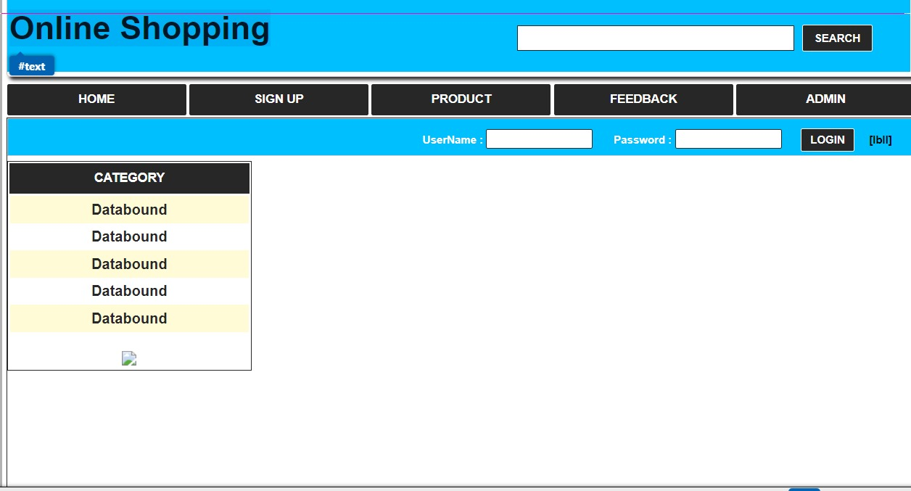

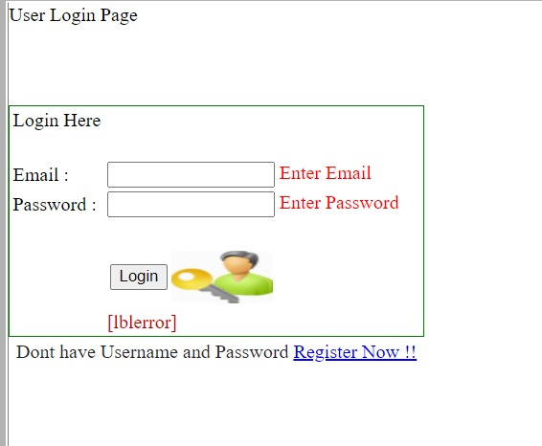

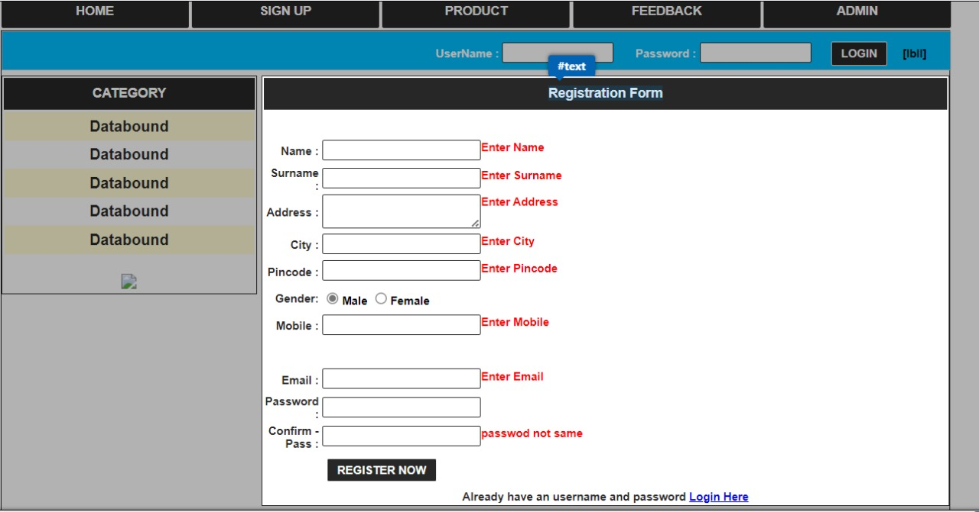

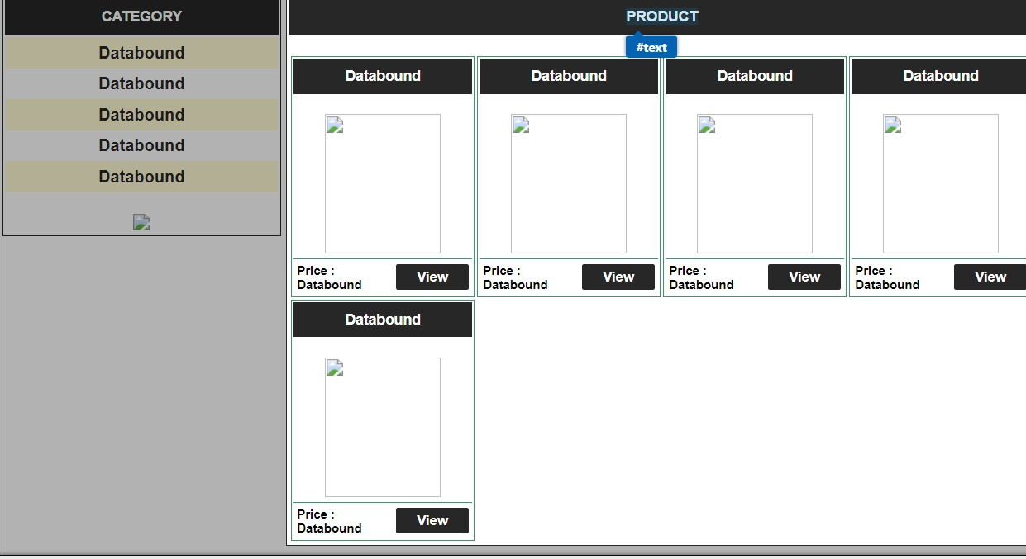

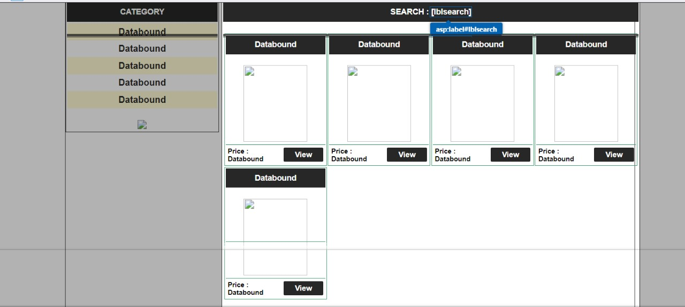

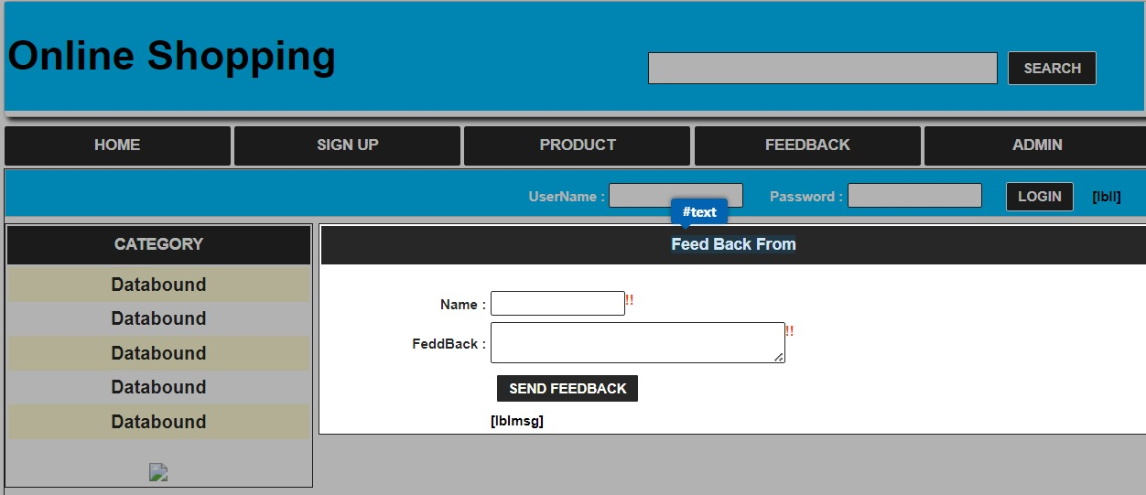

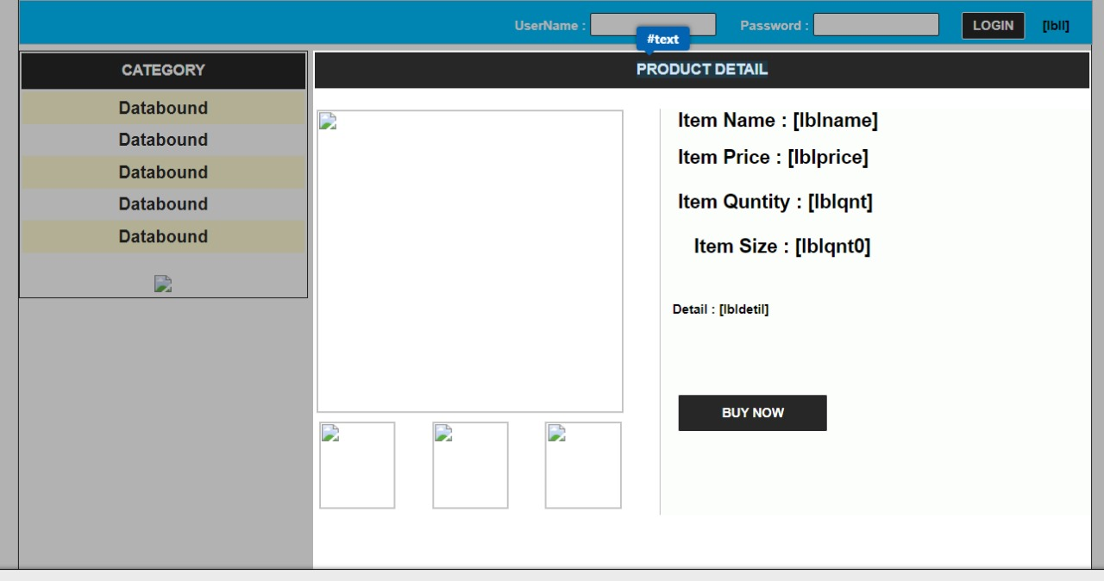

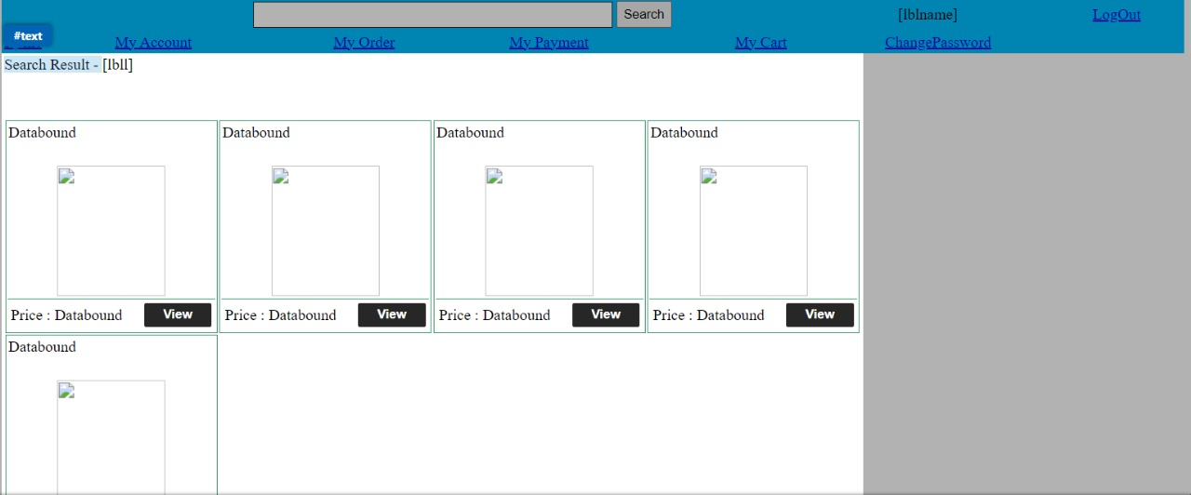

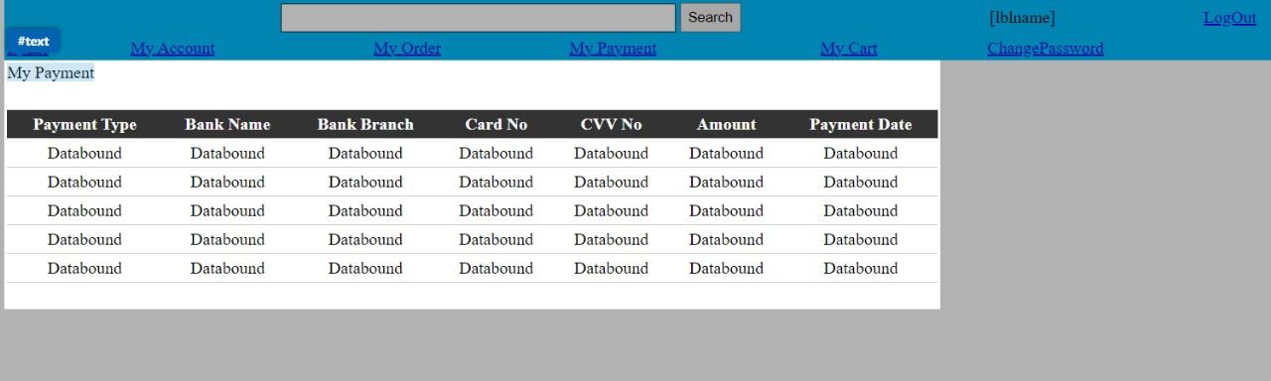

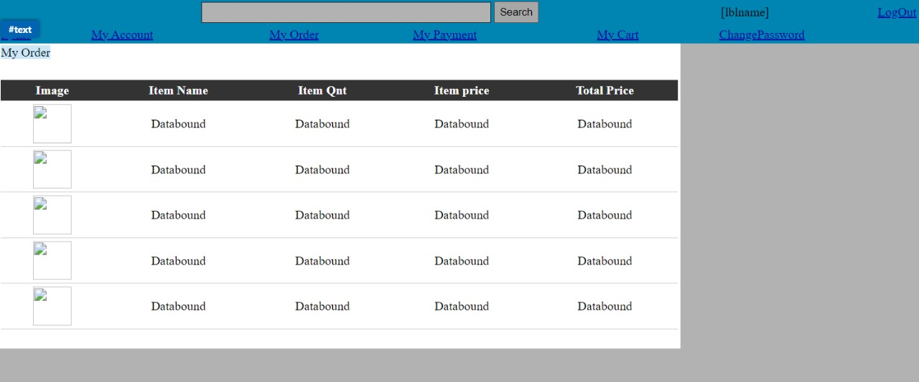

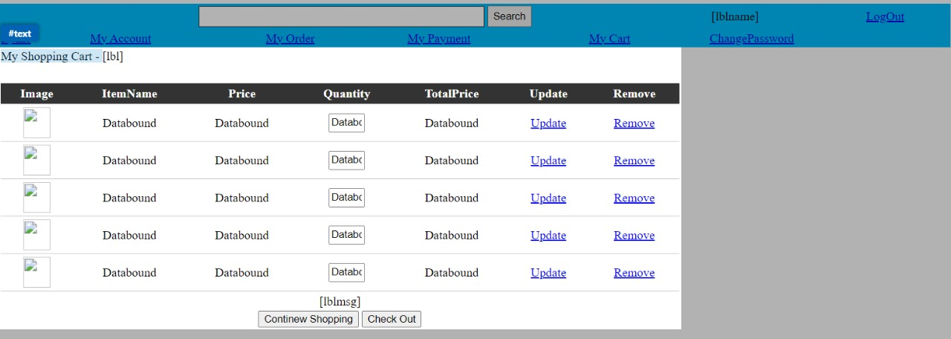

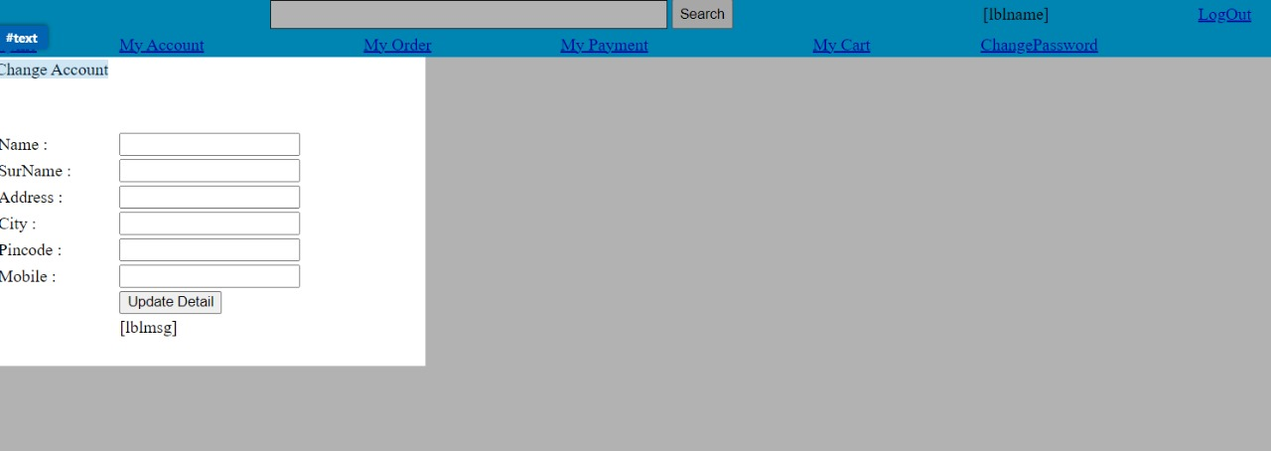

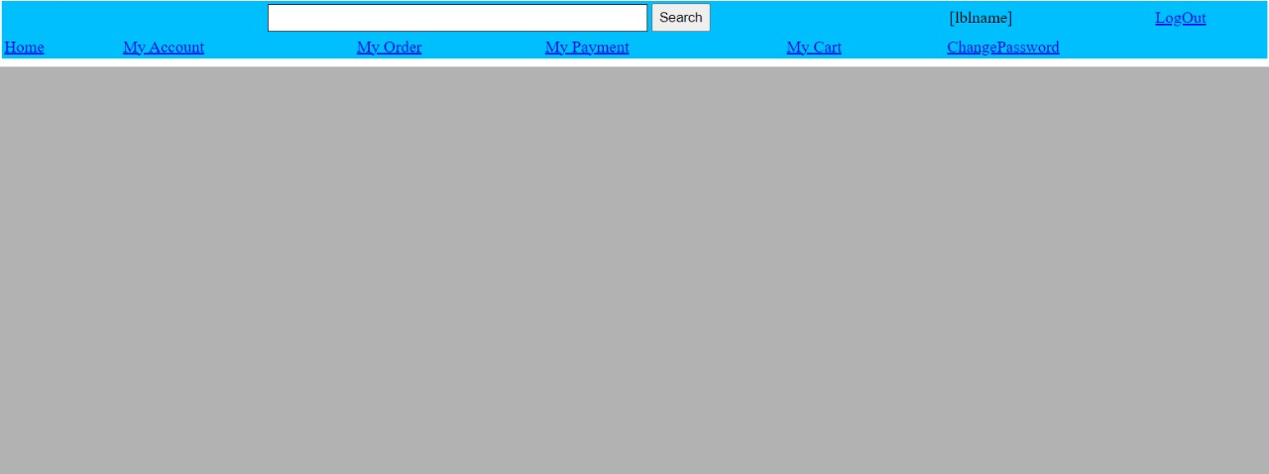

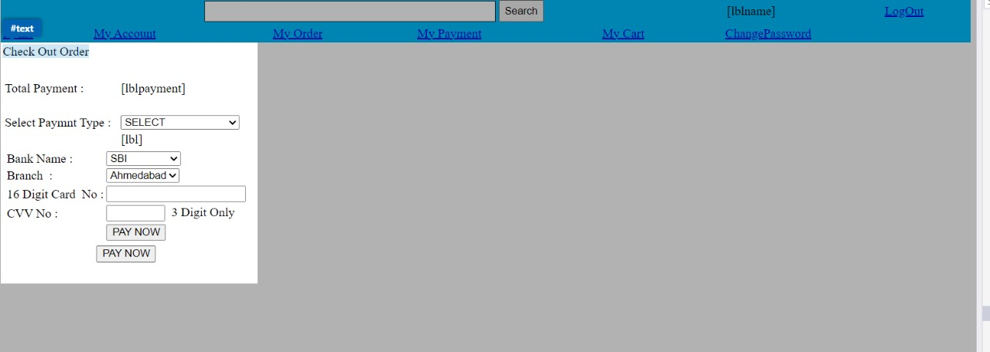

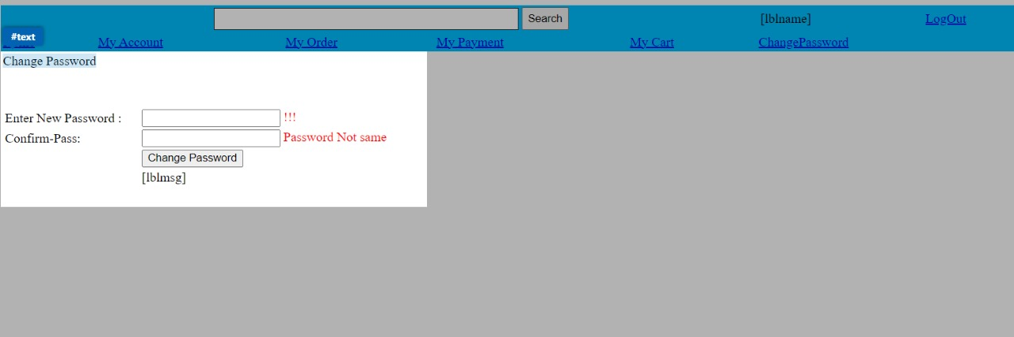

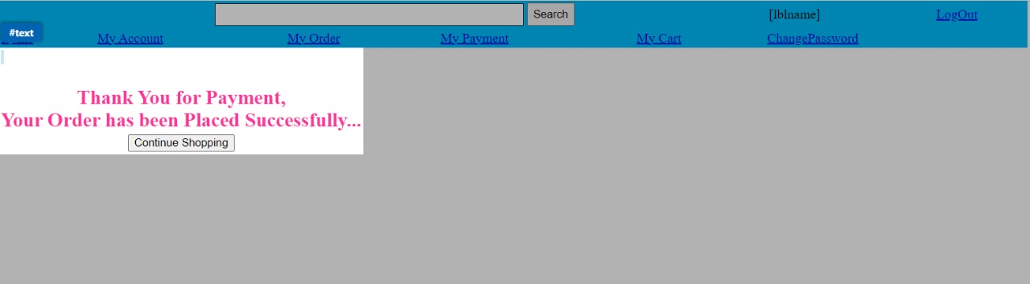

**EER diagram:**

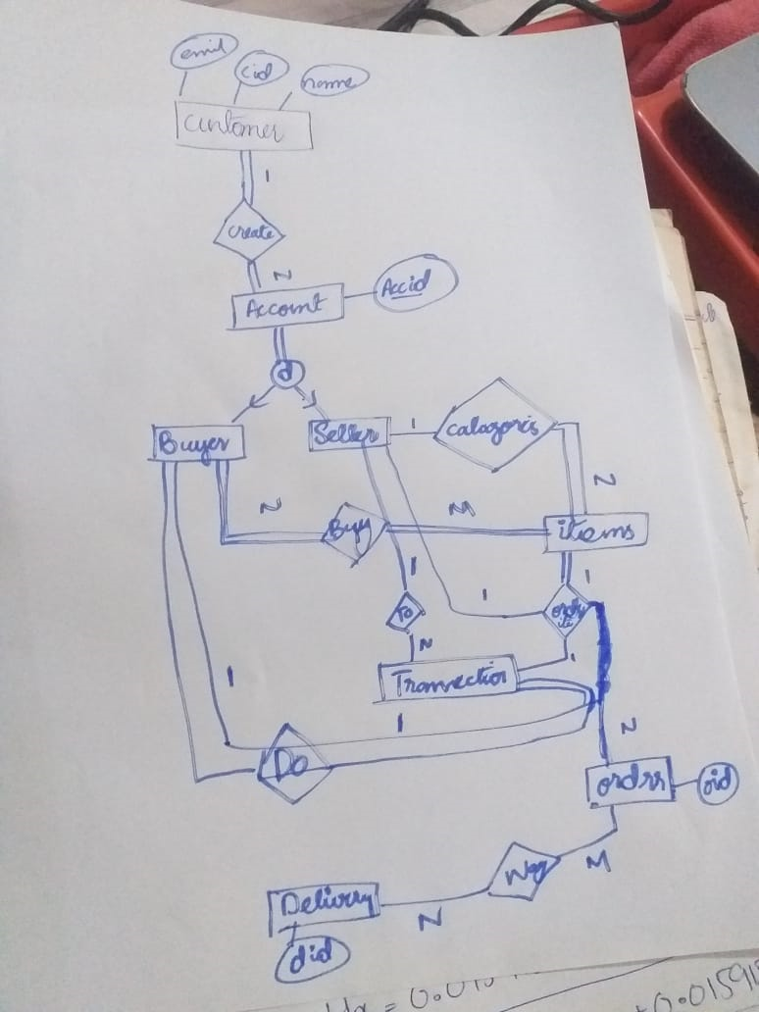

**Relational Model:**

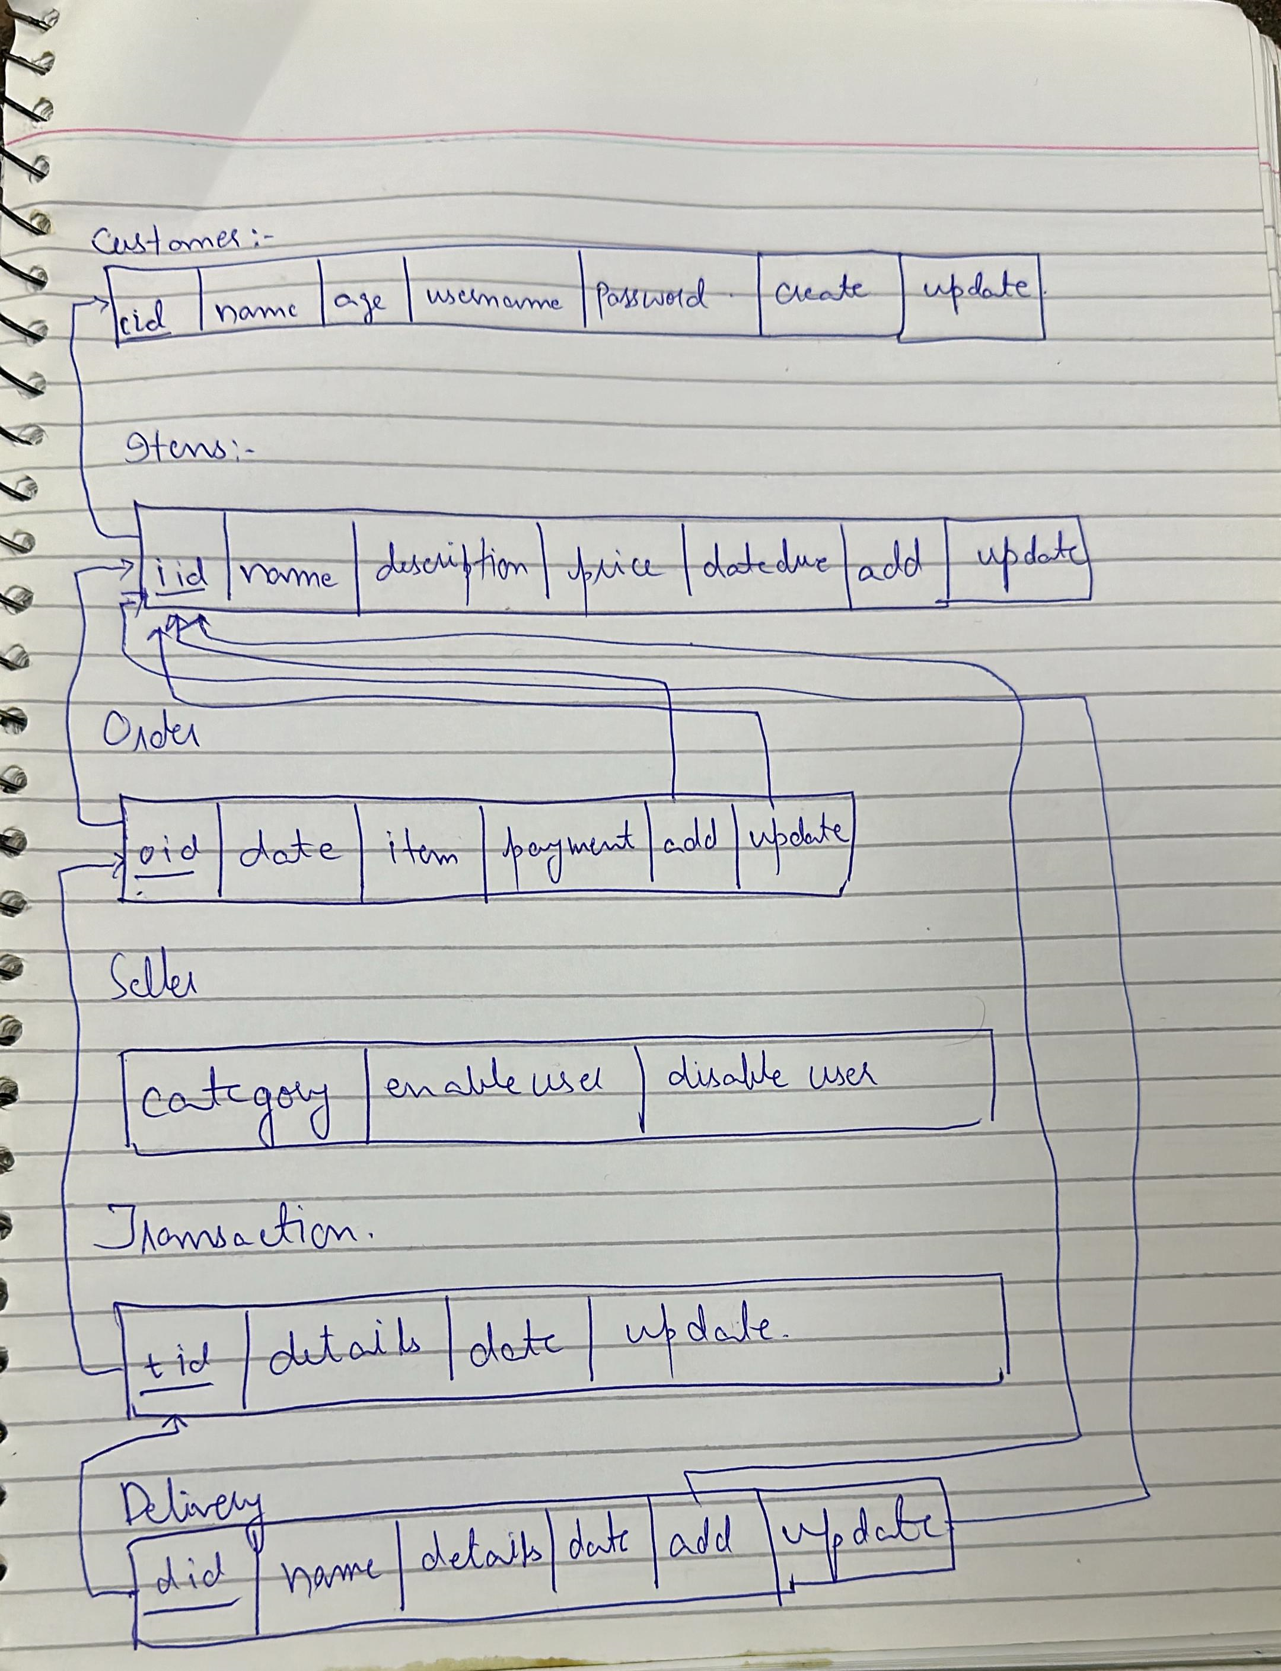

**Conclusion:**

The proposed changes aim to address existing challenges and enhance the functionality of the Customer Management System. By implementing these improvements, the system will be better equipped to manage user data, transactions, and feedback, ultimately leading to a more efficient and user-friendly experience for both customers and administrators.